

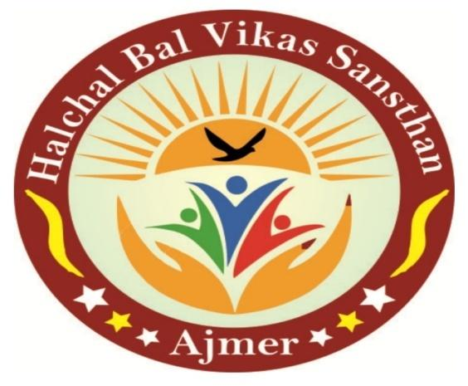

**HALCHAL BAL VIKAS SANTHAN**

**AJMER(Rajasthan)**

***ANNUAL REPORT***

**2020 - 2021**

**ADDRESS: -** Halchal Bal Vikas Sansthan,

Foy Sagar Road, Ajmer 305005

**Phone: -**+91 9660007118, +91 8209946653



***ANNUAL REPORT***

**Mrs.Saroj Rawat**

**President**

**HBVS,Ajmer**

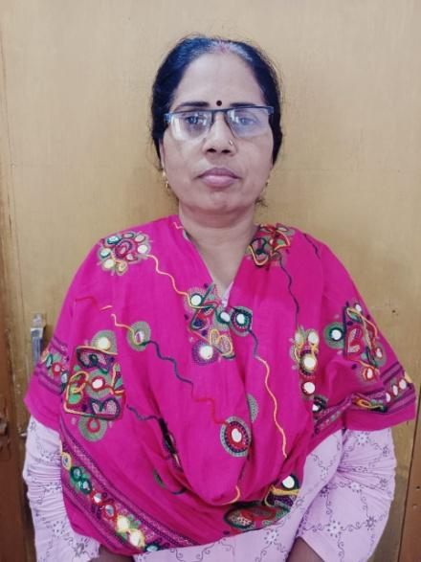The impact of COVID could have affected both community and organization. Even though by the coordination of all workers, volunteers grass root funders, government and non government funders and various social institution of the community and countryside systematically, we conducted superfast activities and program to overcome the key problems such as gender discrimination, women education, child marriage, youth issues and sanitation.

It's my gratitude to those who have supported to overcome the Covid -19 Crisis, especially Government and non-government organizations, tribute to those who hold and hand in all means to reach our destination.

It's my gratitude to those who have supported to overcome the Covid -19 Crisis, especially Government and non-government organizations, tribute to those who hold and hand in all means to reach our destination.

**Mrs.Saroj Rawat**

**President**

**HBVS,Ajmer**

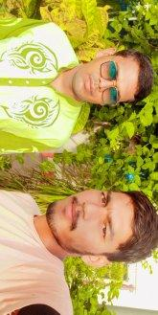Mr.Mohan cheeta

Secretary

HBVS,Ajmer

**From the pen of the Secretary……………………….**

The journey of 6 years in Hulchal Bal Vikas Sanstha was very satisfied. Since the aims of Hulchal Bal Vikas Sanstha to transform the lives of children,youth and women through education, health and empowerment,and youth development to to empower the community. It moving forward in the all field of development. The after effect of COVID 19 can be seen in the life of the people all over the country. Even in those difficult situations, we all worked at community level to muddle through the situation like COVID.

During the COVID timing with the help of all the workers, volunteers and small small fund from the institute, we made zoom calls for children, youth and women in rural areas, and conducted survey of needy families, then we contacted with grass roots funder, gathering material for relief work and more. To reach to the needy people we prepared and distribute masks and motivate more and more people for health services, vaccination, government schemes etc. This has been our experiences which for I would like for thanks everyone from the heart and I look forward to continue with this same cooperation and guidance in the future as well.

Various activities and programs have been successfully conducted by the organization, the detailed description of which is presented as a form of annual report of 2021- 2022.

**I hope that situations like that never come in our lives.**

**May all be healthy and happy and wish you a bright future.**

**Mohan cheeta**

**Halchal Bal Vikas Sansthan**

**About the Organization**

**HALCHAL BAL VIKAS SANSTHAN** is a non-Govt. and non-profit organization registered under the **Societies Registration 161/Ajmer/2015-16 [1-1-2016]** In subsequent decades, this has expanded to include a wide range of activities: primary education, health, early childhood care, and development.

**HALCHAL BAL VIKAS SANSTHAN** always has made an attempt to ensure the **Right to Justice, Peace, Development, no caste, class, gender-based discrimination**; we have worked for a society in which the poor have control on their nature as well as livelihood resources, people co-exist with nature, equality prevails in the society, and the citizens of India have strong moral values.

We are an organization that helps the differently able individuals realize their hopes, dreams, and ambitions and help those who need just a little extra support. Our aim is to create an inclusive society in the village, where people with disabilities are accepted into the mainstream economy and social life.We believe that every single person is special and talented and is just looking for a chance to excel.

A Developmental Approach in which we attempt to initiate processes, make linkages, set in motion problem-solving action and yet an approach which questions the dominant paradigm of “**Development**” We, with The People, are in search of a new definition of “Development” which would respect and take seriously sustainable lifestyles for sustainable development, indigenous people’s social and survival patterns, people’s knowledge, and so on.

**Vision**

By providing social and economic empowerment through behavioural intervention in the community, providing a platform that they become free to keep their point

**Mission**

Participate in the process of upliftment by self-empowerment and better use of available resources to make society self-reliant.

**Areas of Work**



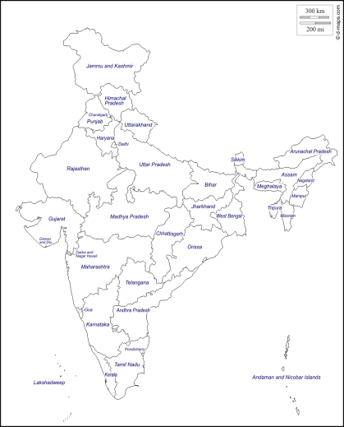

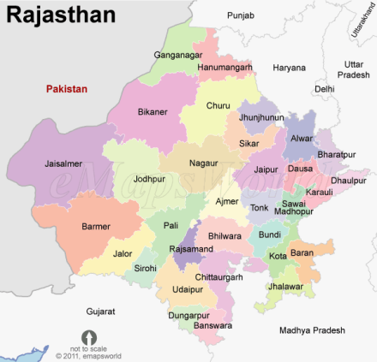

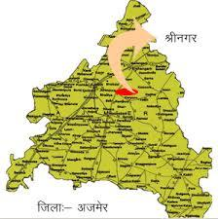



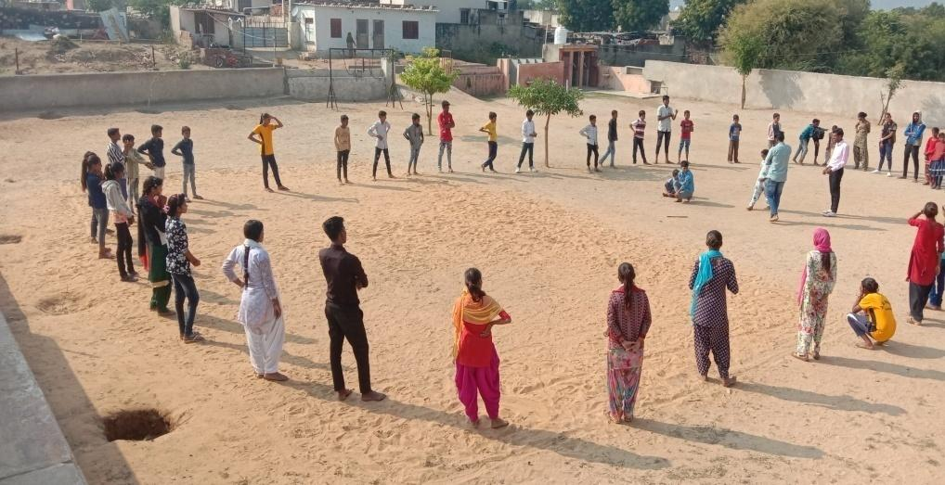

**List of Beneficiaries**

| **Sl. no-** | **Activity** | **Female** | **Male** | **Children** | **Total** |
| --- | --- | --- | --- | --- | --- |
| 1 | Beneficiaries of Health | 82 | 36 | 59 | 177 |
| 2 | Covid beneficiaries | 130 | 126 | 48 | 304 |
| 3 | Rahat Materials | 160 | 165 | 36 | 361 |
| 4 | Trainings | 136 | 265 | 286 | 687 |
| 5 | Linkages with social security schemes | 86 | 12 | 26 | 124 |
| 6 | Educational linkages | 08 | 0 | 43 | 51 |
| 7 | SHG | 120 | 0 | 0 | 120 |
|  | **Total** | **772** | **604** | **498** | **1872** |

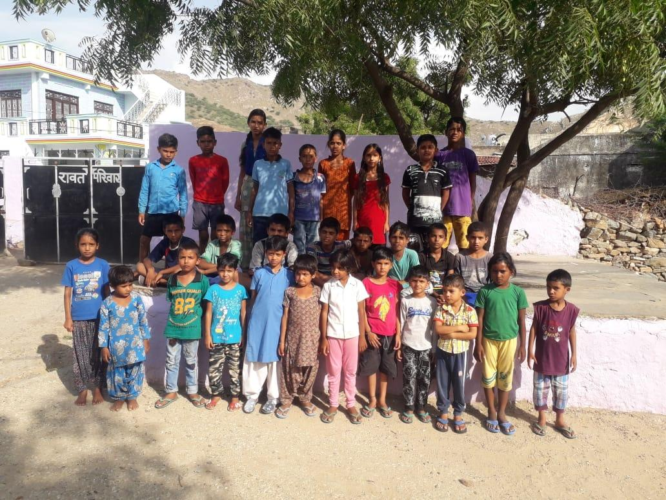

**Activities at a Glance (2020- 2021)**

***Formation of Bal Panchayat***: The organization has formed 7 new bal panchayat groupwithin the panchayat in order to make sure the child rights. This groups help to build the leadership skills within the children by conductingpolitical activities, election of balpanch, formation of groups, child bank, cultural clubs, sports club, library, etc. A total of 210 children are connected through this Bal Panchayat.

***Formation of Adolescent groups***: Both male and female adolescent group formations have been done within the communities of seven villages of Ajaysar Panchayat of Ajmer district. The aim of these groups are aware the upcoming daily life challenges, and how can overcome the challenges. Apart from that awareness on multiple subjects like JeevanKaulshalyaYojana, adolescent health, health and care, pandemic, have been conducting within these groups.

***Monthly Meetings***: Conducted meetings in every month on child rights with children, Adolescents and parents in whichchild marriage, girl child education, health and child welfare were the discussion points.

***Trainings on Child Rights:*** Multiple trainings were conducted on Child Rights. The trainings were included the following topics like Jeevan Kaushal yojana, Adolescent State, Leadership skills, Health and education. These trainings helped the community to increase their knowledge on multiple topics.

***Liaison with local bodies:***Meetings with different local bodiessuch as gram panchayat, community development and school development committees for ensuring the child right at the local level and community level have done. Build play ground for children at community and school level, community hall, Mid day meal system, welfare facilities, public toilet, clean drinking water etc. were the discussion points during the meeting.

***Bal Utsav:*** Every year we celebrate child and youth festival. The festival nourishes and identifies the talents of many children and youth. This year we celebrated child and youth festival on 14th November with the support of community. Different kinds of activities and programs like drama, sports items, exhibitions, film show, cultural programs were conducted. These activities could help to influence and aware people on child rights.

***Education:*** In order to enroll the drop out students from school, multiple programs like community awareness, parents meeting, night meeting, street meeting, students-parents’ meetings, communication with political leaders etc. were done.

Apart from that, different educational activities like follow up of the enrolled drop out students, tuition for students, pre- exam preparations, evening classes, have been organizing.

***Health and Hygiene:***

* Ensured the Anganwadi center services to the community
* SwachBahrat Abhiyan
* Training on De Addiction
* Green village clean village

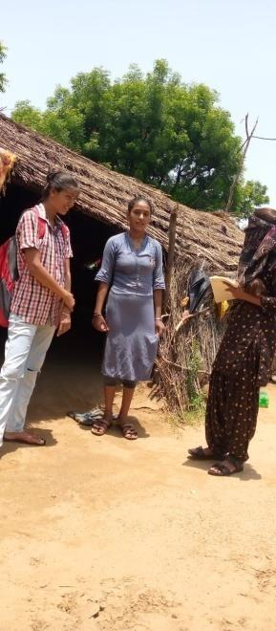

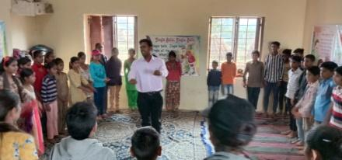

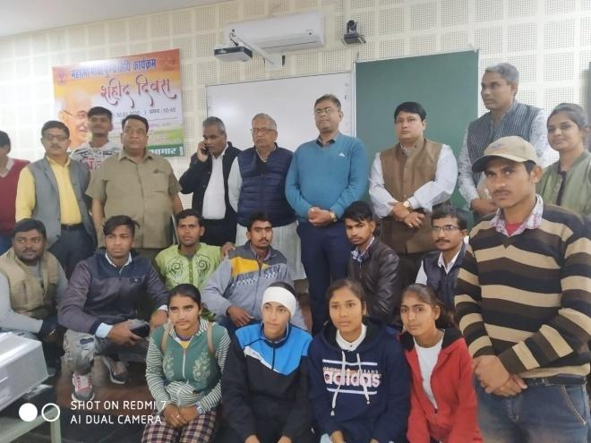

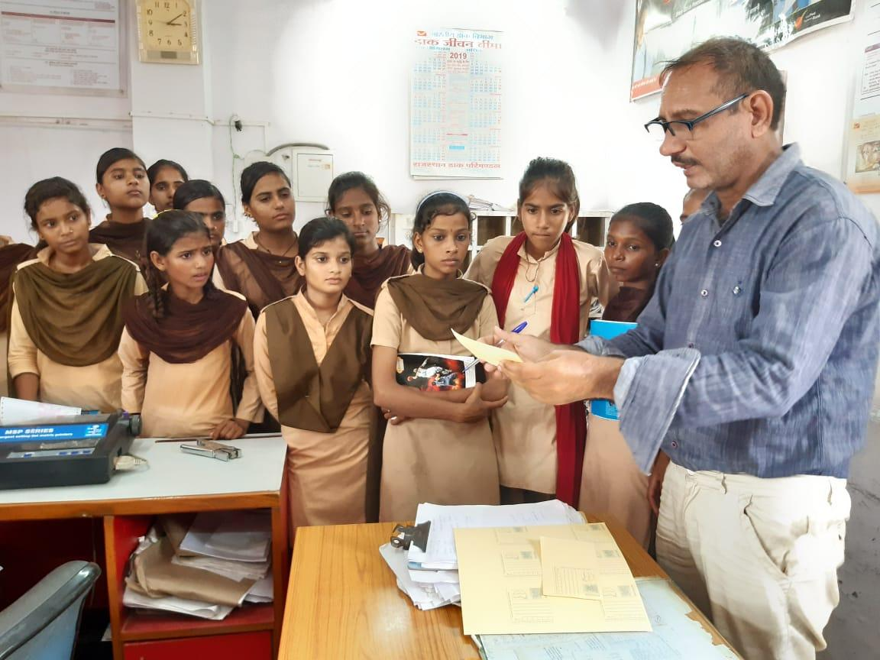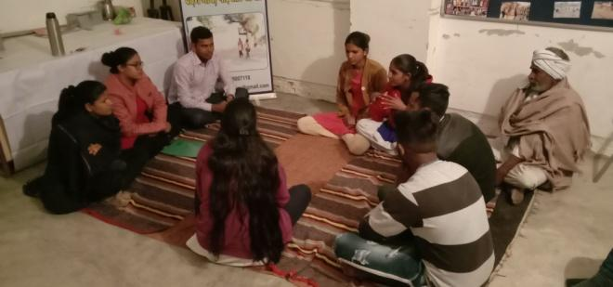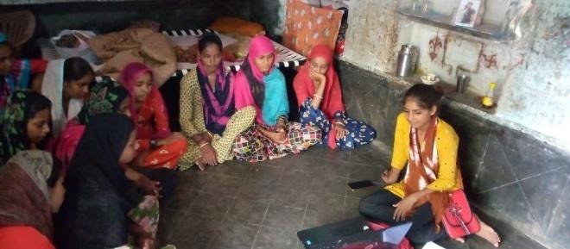

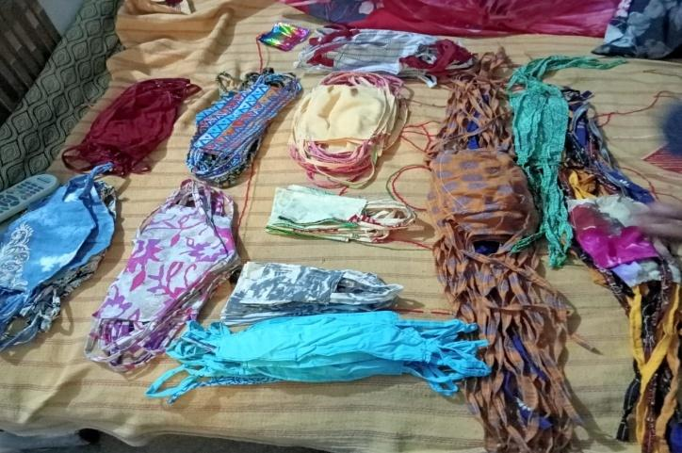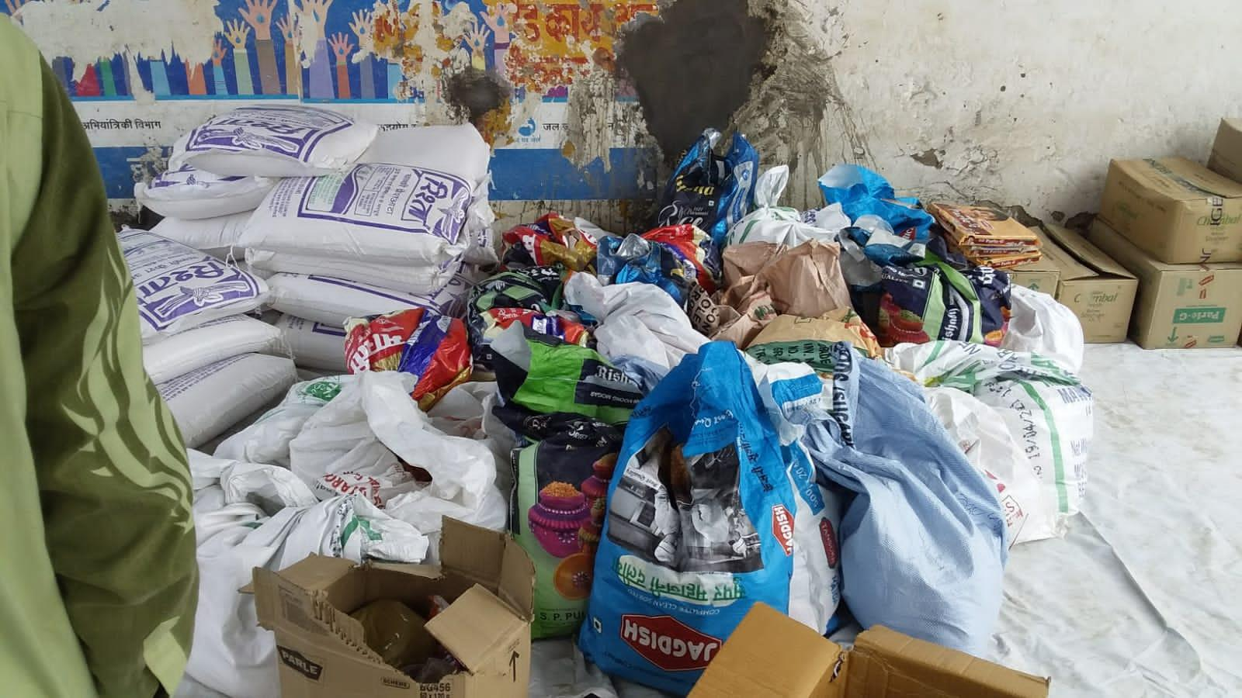***Covid-19:***The rise of covid – 19 has affected the life of people. Many people suffered during the time of pandemic. Public awareness on Covid-19, need base distribution of things to the needy, vaccination awareness, lobbying MGNREGA, distribution of sanitary napkin etc. were done during the pandemic.

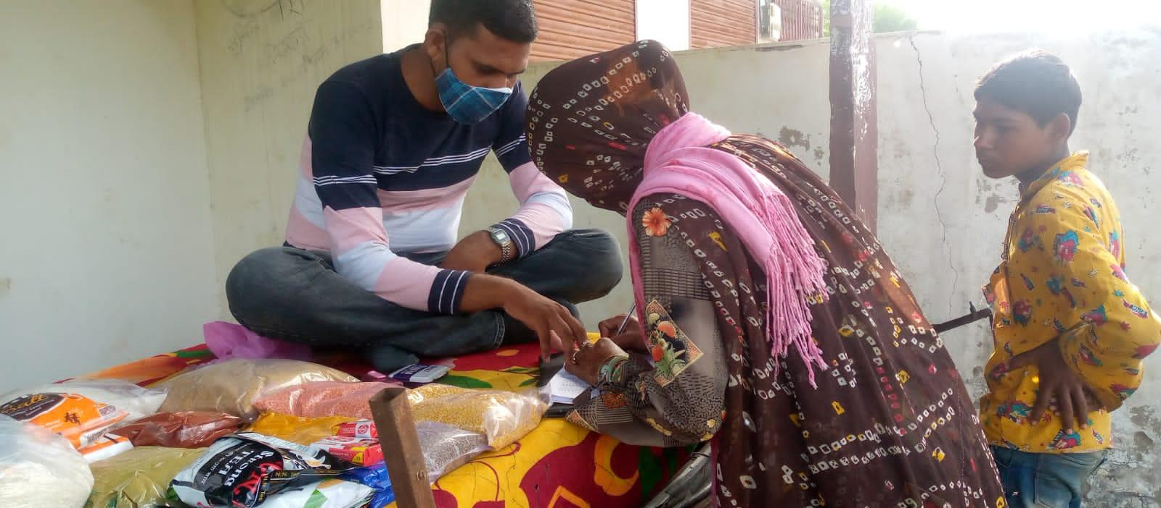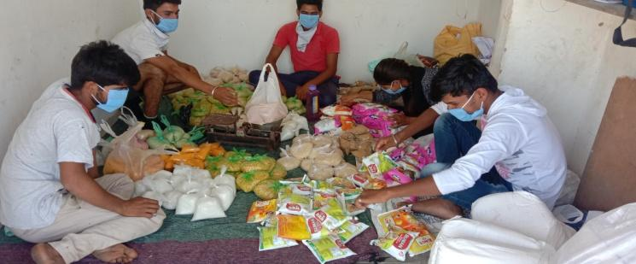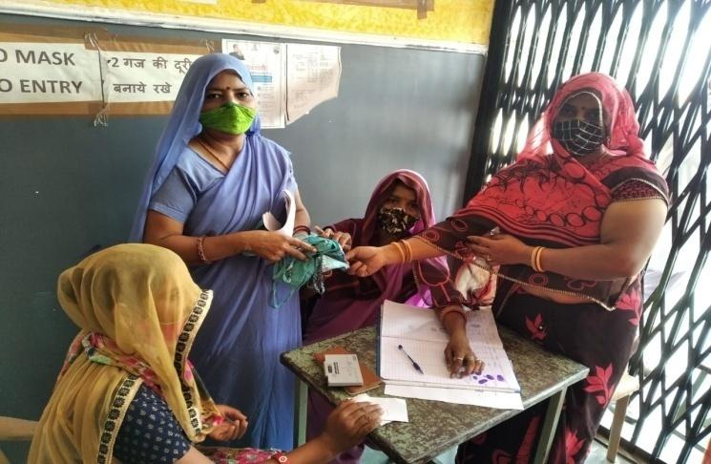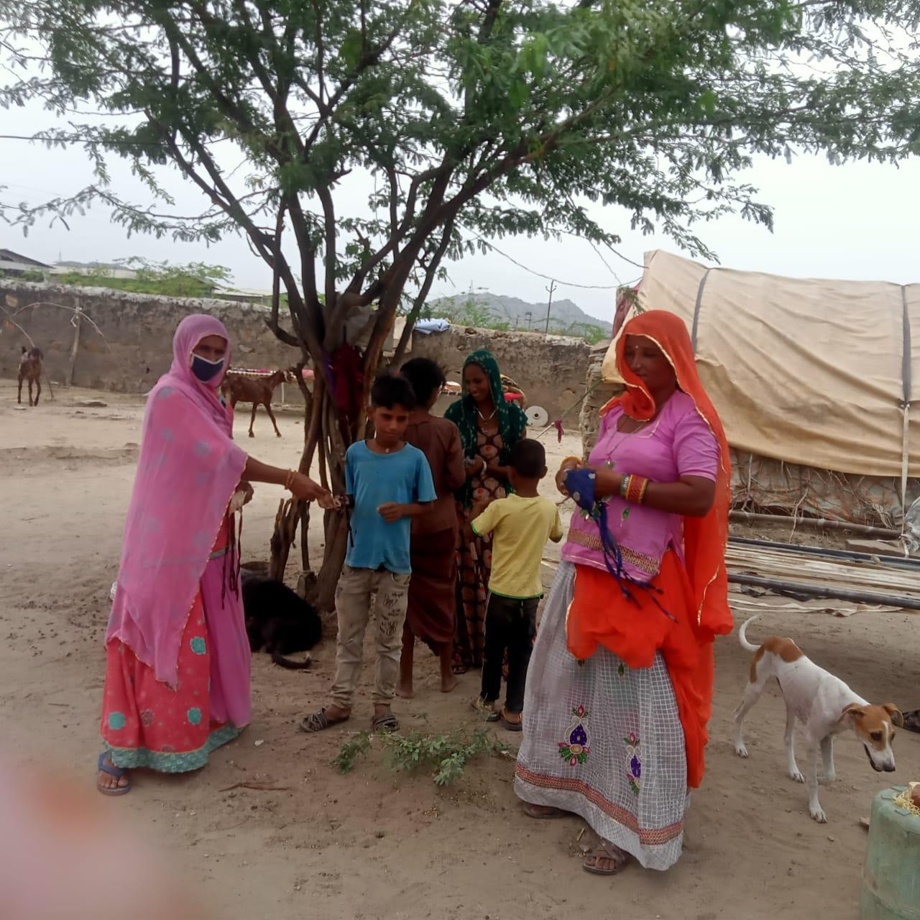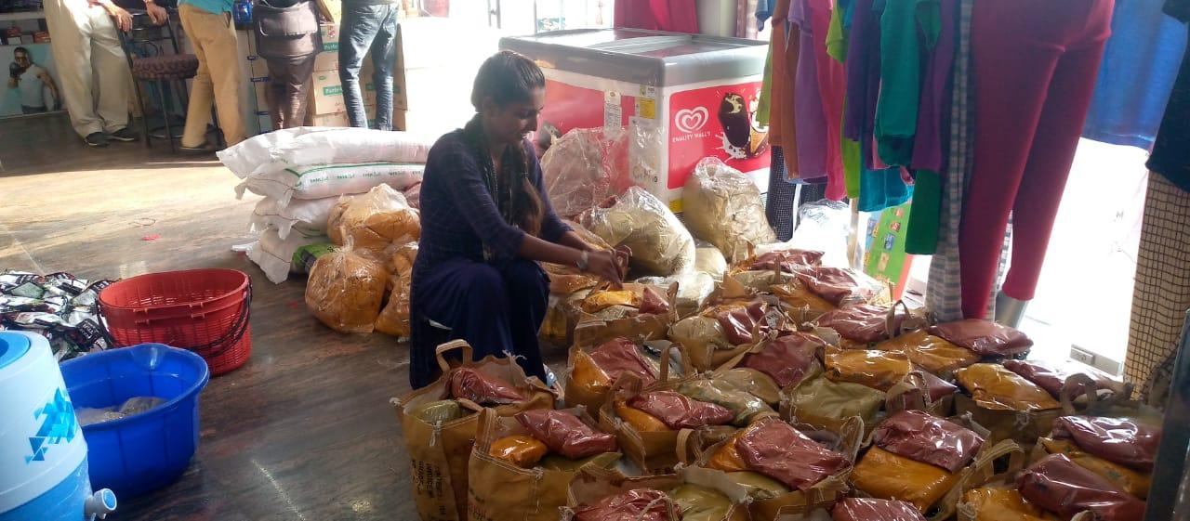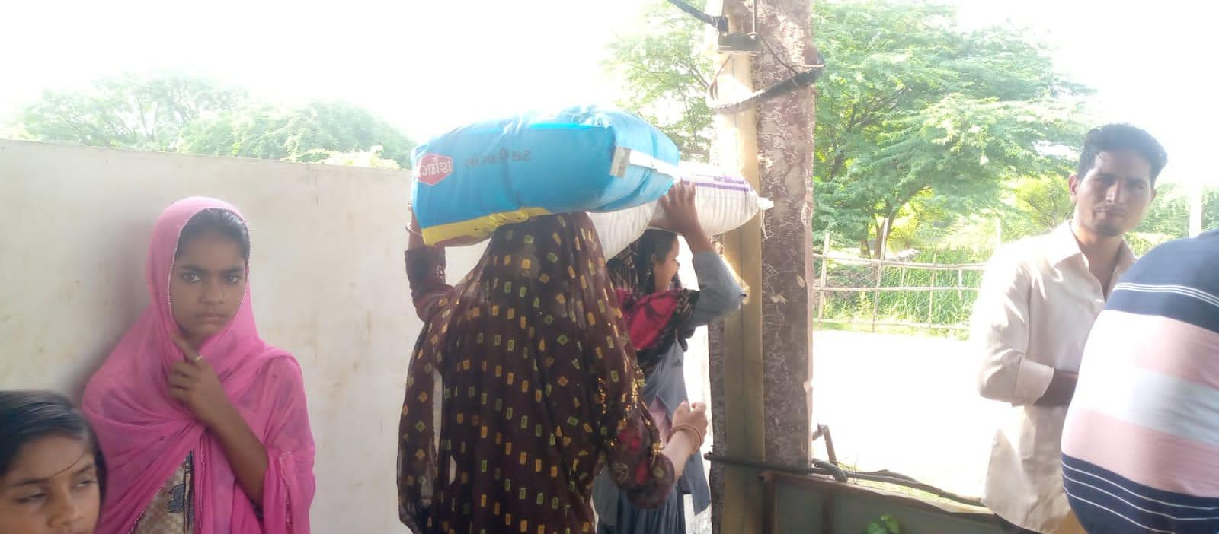

**Youth Engagement and Skill enhancement Activities**

* Formation of youth club
* Girls’ leadership development program
* Capacity building programs
* Made connection with sports items
* Work have been done on social security schemes

**Women Empowerment.**

* Formation of Self-Help Groups
* Linkages with Banks
* Provided support to get loan from banks for Self-Help Groups
* Celebrated women’s day

**Networking:**

We have made positive networking with the following NGO’s and Govt bodies this year.

* Goonj
* CORO
* Gram Panchayat of Ajaysar
* Jan ShikshanSansthan
* SthaniyaSwayanSeviSangathan

**Photo Gallary**

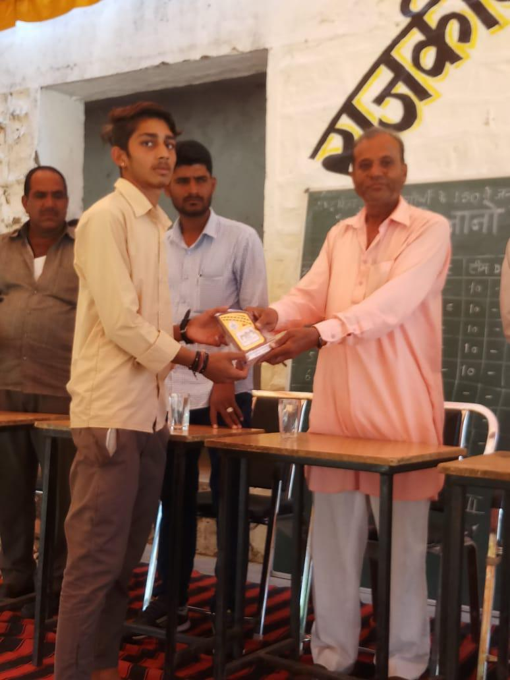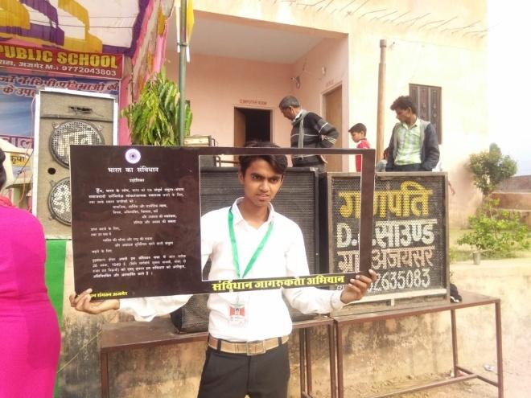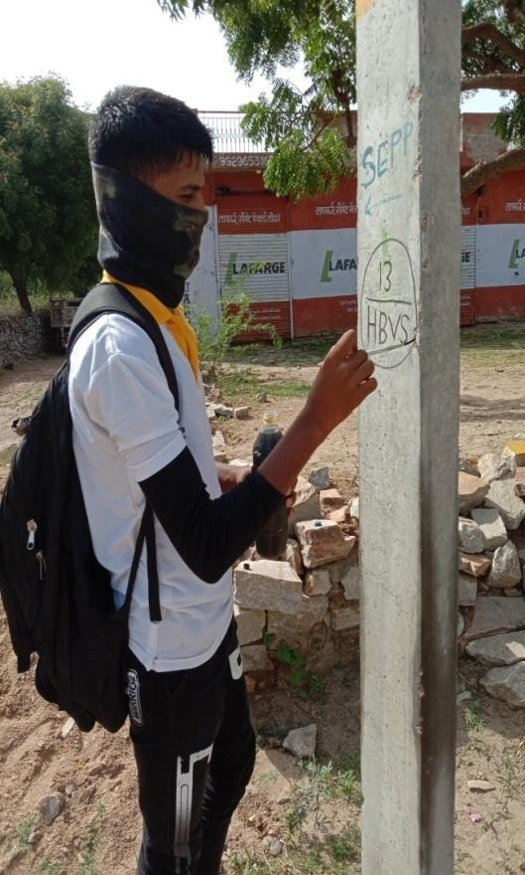

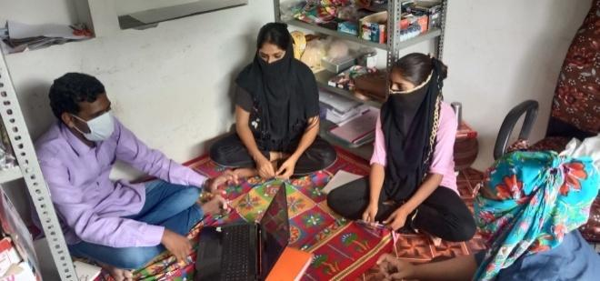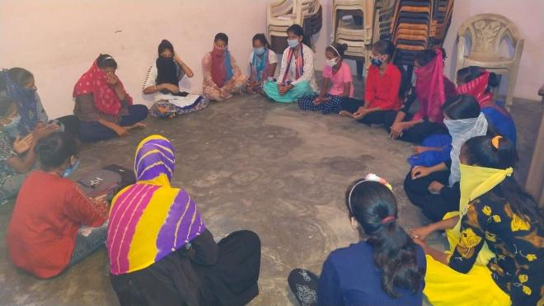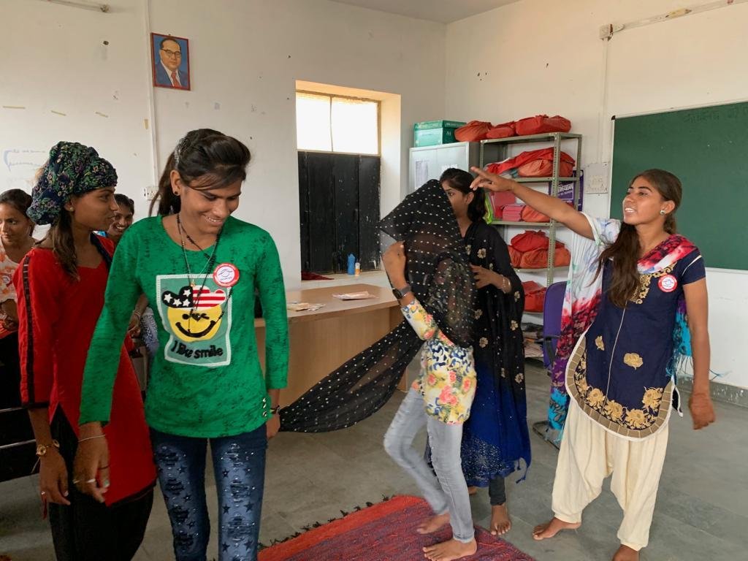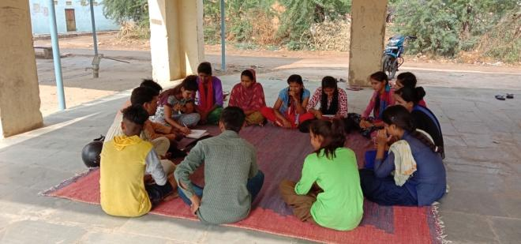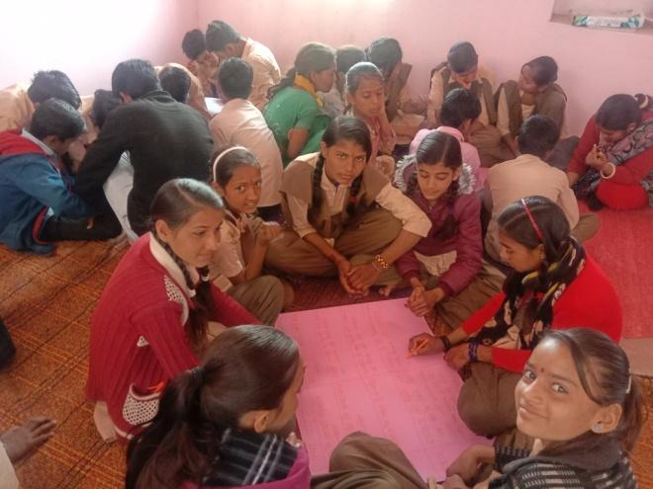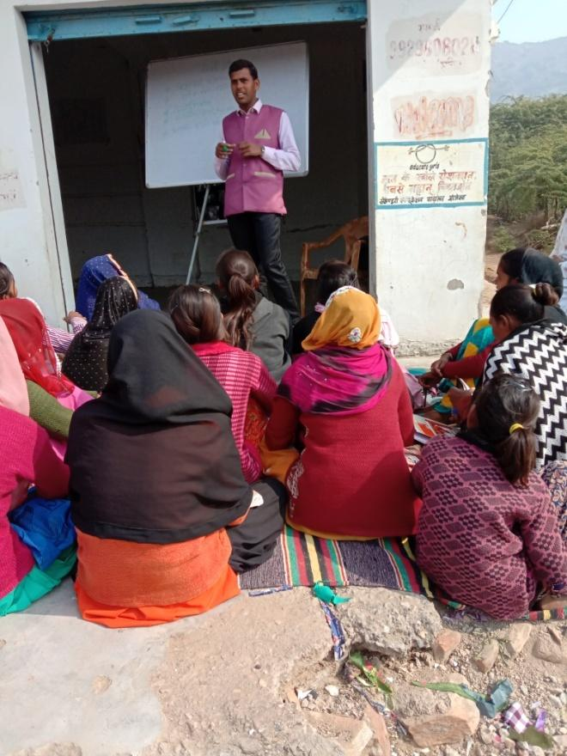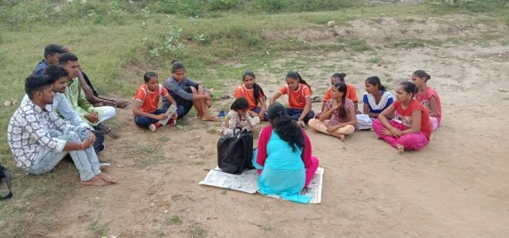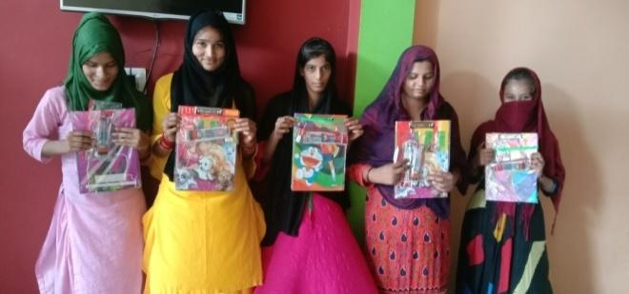

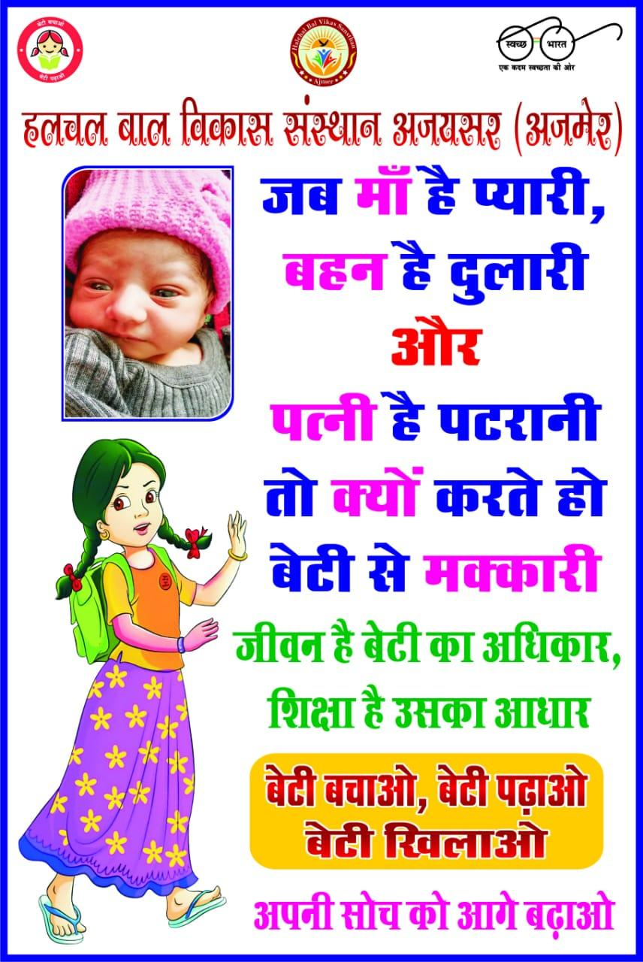**News Cutting**

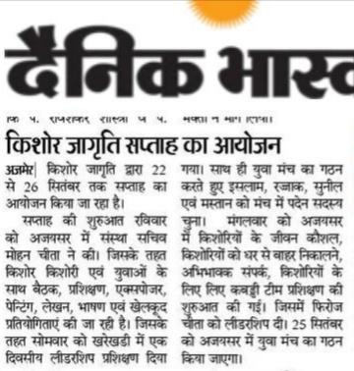

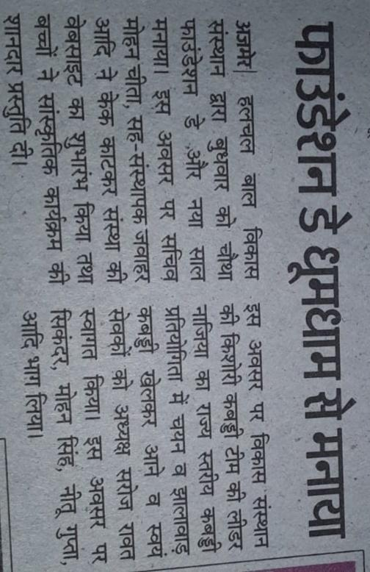

**Certificates**

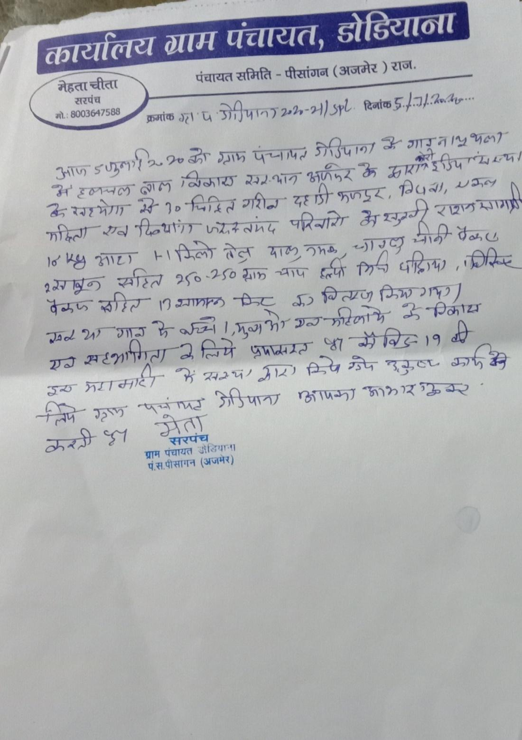

**Thanks**